ROAD SAFETY WALK

The children of Year 4 are taking part in the Practical Child Pedestrian Safety Training Scheme. The aim of this scheme is to develop children’s awareness and understanding of their road
Environment. The children are also completing a ‘Step Out with Skooter’ workbook and will take part in a supervised pedestrian walk on a pre-planned route near the school on Wednesday 26th October 2016.
COFFEE MORNING

The school Enterprise Team are holding a Coffee Morning on Thursday 27th October in the After Schools building from 9.00 a.m.—11.30 a.m. Everyone is invited to come along and support the Enterprise Team.
ENTERPRISE SHOP
The Enterprise Shop in school will be open on Thursday 27th October from 12.30 after children have had their lunch. Items on sale range in price from 10p to £1.
SEARCH FOR THE STARS
The children of Years 6/7 have been invited by Strabane Academy to their ‘Search for the Stars’ show at the Derry Road Campus on Tuesday 25th October. The show will commence at 10 a.m. and finish at 12 noon. A break for the children will be provided during the show.
INTO FILM
The children of Year 6/7 took part in the Into Film IPad Animation Workshop at the Library, Alley Theatre, Strabane on Friday 21st October. The theme for the day was Roald Dahl’s BFG. Pupils were able to animate their own BFG using IPads under the guidance of the Nerve Centre Creative Learning Centre staff.
STUDENT PLACEMENT
This year we have a 2nd Year Student from Stranmillis College on placement in school. Miss Walsh will work between the Year 1 and Year 4/5 classes. To begin with Miss Walsh will be present for a number of day visits and observation days—she will then complete a 6 week block placement commencing in February working three weeks each with these two classes.
AQE ASSESSMENTS
AQE Assessments will take place on Saturdays 12th and 26th November and 3rd December. Child will sit these Assessments in the school/college they hope to attend when they leave Primary school. We wish the children well!
MAYOR’S SUPER HERO DAY
We are taking part in the Mayor of Derry City and Strabane District Council’s Super Hero Week on Friday 28th October. Children are asked to come to school dressed as their ‘Super Hero’ and pay £1 per child to the Mayor’s nominated charities which are Tearfund and Action Cancer. Please recycle costumes you may already have from previous non-uniform days. We have asked the Mayor if she will be able to fit in a visit to our school but are unable to confirm this at the moment.
BAGPIPE TUITION

Bagpipe tuition continues each Tuesday afternoon with Darren Milligan. We have a number of new children this year who are availing of this opportunity.
Artigarvan Primary School and
Community Nursery

31 Berryhill Road, Artigarvan, Strabane, BT82 0HN
Tel: 71883684
www.artigarvanps.co.uk
October 2016
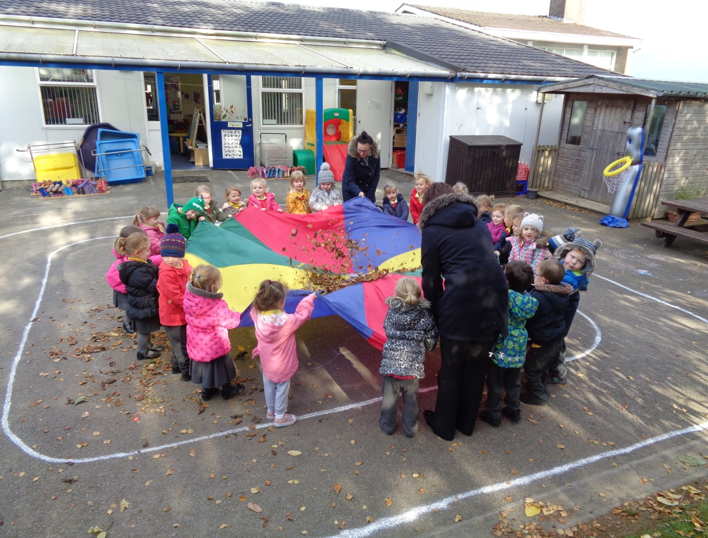
RSERY PARENT INTERVIEWS

Nursery parent interviews will take place after the Halloween break and will be conducted from week commencing 14th November. More details will be posted in Nursery shortly.

The children of the Nursery having fun with some autumn leaves
in their parachute

HALF TERM HOLIDAY
School and Nursery will be closed from Monday 31st October to Friday 4th November inclusive. School and Nursery will re-open on Monday 7th November.
CULTURE QUARTER WORKSHOPS
We have been given the opportunity to take part in a number of workshop organised by Derry City and Strabane District Council to promote diversity and understanding amongst primary-school age children. The workshops our children will be taking part in will be:
Year 6/7—’Identity Kit’ - this workshop will include discussion/interative powerpoint on aspects of identity—race, religion, nationality, language and arts based activity with an anti-prejudice/respect message.
Year 2/3—’Identity and Faith’ - this workshop will include discussion and activity on world faiths and personal and cultural identity.
Year 4/5—’The Story of Derry’ - this workshop will include a free visit to the Council’s award winning Tower Museum with a guided tour through the ‘Story of Derry’ Exhibition. The tour uses a wide range of techniques and artefacts to narrate the story from Monastic times, the Plantation, the Siege of Derry, through to the 18th, 19th and 20th Centuries including Partition, the build up to the Civil Rights Movement and the impact of the troubles on the people living here. The exhibition ends with a glimpse of life today.

All of the workshops will take place on 24th and 25th November.
EXTENDED NURSERY
Extended Nursery is now available for all children of the correct pre-school age. It costs £2 per day and children can stay from 11.30 a.m. to 12.30 p.m. The list of children eligible to stay can be viewed in the Nursery porch.
FLU VACCINATION PROGRAMME
The flu vaccination programme will be carried out by the school nursing team and is due to take place on Wednesday 16th November. Only those children who have indicated on their form that they wish to receive this vaccination will be vaccinated.
HIGHLAND DANCING

Highland Dancing continues each Friday afternoon and we are delighted to see some of our Nursery children in attendance for their class from 1.15—1.45 p.m. The class for children in Years 1—3 runs from 2.00—2.45 p.m. and for Years 4—7 from 3.00—4.00 p.m. The fee is £1 per week.
CHILDREN NOT ENROLLED

If you have younger children at home or you have family or friends with young children who are not yet at Nursery please complete the form attached to this Newsletter. This will help us to distribute Application Forms for Nursery when they become available at the end of
November.
KICKSTART COACHING

Kickstart Coaching continues each Monday from 3—4 p.m. Coaching costs £2 per session and is open to both boys and girls in Years 1—7.
SCHOOL DINNER MENU

Attached you will find a new school dinner menu. The menu starts on Monday 7th November with Week 4.

PUPIL COUNCIL
The children of each class voted recently to elect 2 members to the Pupil Council. The elected members are:

Year 1: Kiara and William Year 2/3: Leah and Olly
Year 3/4: Megan and Ron Year 5/6: Leah and Jenna
Year 6/7: Lydia and Cody

A Pupil Council:
• gives pupils a chance to make changes for the better in their school
• gives pupils a forum for discussion
• is one way of giving pupils a say in the way the school is run
• gives pupils a VOICE in school matters
• gives pupils an opportunity to talk about their feelings to each other and to teachers
ECO COMMITTEE

Pupils elected recently to serve on our ECO Committee for the 2016/17 school year are:

Year 1: Chloe and James Year 2/3: Brooke and Harry
Year 3/4: Millie and Owen Year 4/5: Amy and Lauren
Year 6/7: Charlie and Kyle

The ECO Committee have been in touch with Derry City and Strabane District Council’s Waste Management Administrator—Yvonne Lecky—who will visit the Nursery and School on Friday 18th November and will deliver a presentation on the benefits of recycling, etc.

To this end we remind parents of our clothing recycling bin at the school gates and also that we recycle batteries and ink cartridges.
HALLOWEEN SCARECROW TRAIL

The children of Year 3/4 have been busy making a scarecrow following an invitation from Derry City and Strabane District Council. The scarecrow trail is part of the implementation of the Strabane Town Forum and MourneDerg and Glenelly action plans for the Halloween activities. Our scarecrow will be displayed alongside other schools and playgroup/nursery entries in a range of shops in our local town/village.
JUNIOR ROAD SAFETY COMMITTEE

The Junior Road Safety Committee have organised another competition. The competition for children in Nursery is to design a road safety jacket. Children in Year 1 - Year 4 are asked to complete a sheet entitled ‘Safe Crossing Places’ while the children in Years 5—7 are taking part in a ‘Road Safety Quiz’. The closing date for all our road safety competitions is Thursday 10th November and completed entries should be placed in the appropriate box that can be found in the front hall of the school. Good luck everyone!
BOOK FAIR

Our Travelling Book Fair was collected again on Friday and we are delighted to report that takings at the Fair amounted to £622.62. This means we can purchase books to the value of over £300 for school and nursery. Well done and thank you to everyone who supported our Book Fair!

